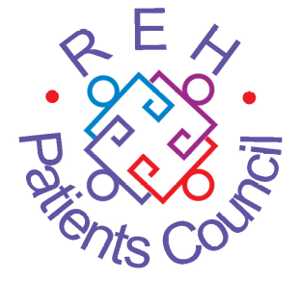

APPLICATION FOR EMPLOYMENT
POST: Finance, Administration & Business Officer-
(FAB Officer)
Royal Edinburgh Hospital Patients Council (SCIO)
Hours per Week: 20 - (Part Time)
Hours per Month: 80

Surname:

Initials:

Address:

Postcode:

Telephone no:

- Please use this application form – we do not accept CVs as valid applications
- Please write or type in black ink on one side of the paper only
- Please do not give your name on other pages as this page will be removed prior to short listing
- Please remember to fill in the Equal Opportunities Monitoring Form and PVG Self Declaration Form and return them separately

If there is anything you would like to discuss regarding this application form please contact us on 0131 537 6462
EDUCATION AND TRAINING

Please detail any education and training you have received that is relevant to the post. Please state when and where the qualification and/or training was received, the qualification achieved and a brief explanation of the content.

EMPLOYMENT HISTORY

Please list any employment, paid and/or unpaid that is relevant to the post starting with the most recent first. Please feel free to continue using additional space if necessary.

Please state:

- Name and address of the employer
- The dates you were employed there
- Your job title
- Your duties and responsibilities
- Whether you were paid or unpaid

ADDITIONAL INFORMATION

Having read the Job Description, please detail below what training, experience, knowledge and ability you have which make you suitable for this post. You should make direct reference to each point on the Person Specification. Please feel free to use extra space if necessary.

REFEREES

Please give the name, address and telephone numbers of two referees. One of the referees should be your current or most recent employer. Referees will only be contacted in the event that you are offered the post.

1) Name:

Address:

Email:
Telephone:

2) Name:

Address:

Email:
Telephone:

Please state whether you have any special requirements if called to an interview. If yes we will contact you prior to the interview.

YES NO

Description of requirement:

Please return completed forms to: REH Patients Council
Andrew Duncan Clinic Royal Edinburgh Hospital
Morningside Place
Edinburgh EH10 5HF
Or email to: Carolyn@rehpatientscouncil.org.uk Closing date: Friday 3rd July 2026

